Hotel Resort App

**Software Requirements Specifications**

CEN 3031, Choose an item. Choose an item.

|  |  |
| --- | --- |
| **Target Release Date** | **12/06/2019** |
| **Team Name** | The Resorters |
| **Team Members** | 1. Romanov Andre  2. Stephen Aranda  3. Shafi Mushfique |

Contents

**Project Title**. 1

Software Overall Description. 1

User Interactions. 1

Assumptions. 1

Use Case Diagram.. 2

Use Case Descriptions. 2

Specific Requirements (Product Backlog/Shall Statements) 2

Version History. 2

# **Software Overall Description**

Provide the context of the project and the strategic goals it is being designed to meet

The Hotel Resort application is a java-based software. It is being designed with the purpose of simplifying the process of hosting a resort for all parties involved (customers and owners). In the case of a customer, the software allows them to reserve a spot at the resort; and to view and book hotel rooms with the aid of a virtual transaction system. In the case of an owner, the software allows them to receive payments, view transactions, and monitor employees (custodians and receptionists).

# **User Interactions**

## 

## **Assumptions**

List any assumptions about: Users; Technical Constraints; Business Goals; or etc. (*Most users will access on tablet; Internet access will be available for Cloud features*)

We assume that all our users are at least 18 since our software does not verify this information.

We assume that all users will access our application on a computer/laptop because that is currently the only platform our software is available on.

We assume that users know that their credentials is stored in a database that does not provide encrypting.

We assume that users provide non-fraudulent card information for a payment since currently the system does not have this capability.

## **Use Case Diagram**

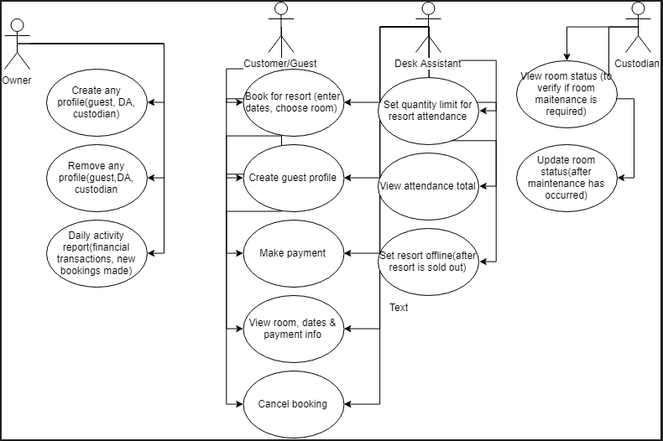

## **Use Case Descriptions**

|  |  |  |  |  |
| --- | --- | --- | --- | --- |
| **ID#** | **Title** | **Description** | **Priority** | **Additional Notes** |
| **1** | Account Registration | **As a** user **I want** to register an account **so that** I can access software | Choose an item. | Click or tap here to enter any additional requirements. |
| **1** | Add Employee | As an owner I want to be able to create/delete any profile (guest, desk assistant, custodian) from the software so that I can manage employees | 2 |  |
| **2** | Book Room | As a customer I want to be able to book rooms (enter room #, dates) through their profile so that I can have a hotel to stay at. | 1 |  |
| **3** | Check-in customer | As a desk assistant, I want to be able to perform all the actions that a Customers can within the system so that I can assist a customer in booking a room #, etc. | 3 |  |
| **4** | Maintenance | As a custodian, I want to be able to view all the room at a hotel so that I can maintain the room’s status. | 4 |  |

## **Specific Requirements (Product Backlog/Shall Statements)**

|  |  |  |
| --- | --- | --- |
| **Task Name** | **Task Description** | **Status** |
| **Sprint 1** |  |  |
| **Task 1** | The system shall provide a detailed daily report containing financial transactions and user activities to owners as a way to stay updated. | completed. |
| **Task 2** | Customers shall be able to create a profile as a way to save their activities/information within the system. | completed. |
| **Task 3** | Customers shall be able to book rooms (enter room #, dates) through their profile. | completed. |
| **Task 4** | Customers shall be able to make a payment through their profile to pay for their transactions. | completed. |
| **Task 5** | Customers shall be able to view their assigned room and their financial transactions through their profile to view their activity details. | completed. |
| **Task 6** | Customers shall be able to cancel a room through their profile in case they no longer want to attend the resort. | completed. |
| **Task 7** | Customers/Desk Assistants shall be able to view the amount of attendees to know how close the resort is to being sold out. | completed. |
| **Task 8** | Desk Assistants shall be able to perform all the actions that a Customers can within the system as a way for a DA to assist a customer in booking a room #, etc. | completed. |
| **Task 9** | Desk Assistants shall be able set the resort offline through their profile when the resort is sold out. | completed. |
| **Task 10** | Custodians shall be able to view room status from the system in order to provide room maintenance when necessary. | completed. |
| **Task 11** | Custodians shall be able to update a room's status within the system after room maintenance has occurred. | completed. |
| **Sprint 2** |  |  |
| **Task 12** | Customers shall be able to create a new account it should create a table for them on the database | completed. |
| **Task 13** | The system shall add a customers information to the customer table in the database | completed. |
| **Task 14** | The system shall generate a new invoice no/order no when a customer books a room | completed. |
| **Task 15** | The system shall accommodate that when a customer will book a room it should add their information in three different table- 1/ The information should be sent to the table named after customer with tat unique order no , 2/It should be also sent to the table "Invoice No" (That table will save all the booking history) with the same unique invoice no. 3/It should also save the information to the Room No table. | completed. |
| **Sprint 3** |  |  |
| **Task 16** | The system shall comprise of three tabs for a customer profile: booking, transaction, and booking history. | completed. |
| **Task 17** | The system shall pop up error when it found a similar booking on the same room category(Conflict of date and suggest customer for booking a different room or different date | completed. |
| **Task 18** | The system shall have a logout function in order to sign-out a user. Also, a back button from the login screen to navigate to the previous screen | completed. |
| **Task 19** | The system shall allow the owner to create an account for each of the employees that will work there. | completed. |
| **Task 20** | The owner account shall be able to reset the password for each employee and customer when he will be provided the account PIN for the individuals' account. Then the owner has to enter that username, pin and Owners account own password to create a temporary password for the users. | completed. |

# **Version History**

|  |  |  |  |
| --- | --- | --- | --- |
| **Version Number** | **Date** | **Change Description** | **Editor** |
| **V1.001** | 11/01/19 | The user interface is about 50% completed overall. The UI buttons work connecting the UI scenes when they are pressed. | Stephen Aranda |
| **V1.002** | 11/14/19 | The UI is about 75% completed overall. The information is saved in our database. The actions for our actors (customers, owners, custodians, desk assistants) are almost done. | Shafi Mushifaque |
| **V1.003** | 12/06/19 | The UI is 100% completed. All the necessary credentials can be saved in our database. Our actors actions are all completed and work as intended. Our objective for the software is met. | Romanov Andre |